|  |  |  |  |  |  |  |
| --- | --- | --- | --- | --- | --- | --- |
| **Atoms and Macromolecule Guided Notes** | | | | | | |
| **Vocabulary** | | **Definition/Activity** | | | | **Drawing** |
| **Matter** | |  | | | |  |
| **Matter vs**  **Non-Matter** | | Matter | |  | | |
| Non-Matter | |  | | |
| **States of Matter** | | Solid:  Liquid:  Gas: | | | |  |
| **Atom** | |  | | | |  |
| **Nucleus** | |  | | | |
| **Electron Shells** | |  | | | |
| **Protons** | |  | | | |  |
| **Neutrons** | |  | | | |
| **Electrons** | |  | | | |
| **Valence Electrons** | |  | | | |
| On the Reading the Periodic Table Slide?  Go to the bottom of this document. | | | | | | |
| **Element** | |  | | | |  |
| **Pure Substance** | |  | | | |  |
| **Compound** | |  | | | |  |
| **Molecule** | |  | | | |  |
|  |  | | **Macromolecules** | |  |  |
|  | **Carbohydrates** | | **Lipids** | | **Proteins** | **Nucleic Acids** |
| **Structure** |  | |  | |  |  |
| **Function** |  | |  | |  |  |
| **Example** |  | |  | |  |  |
| **Picture of molecule** |  | |  | |  |  |

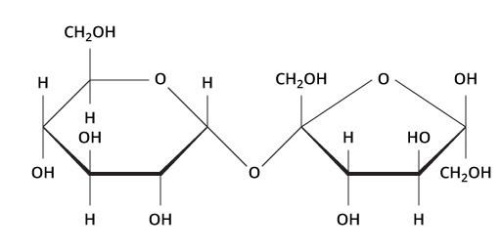 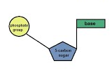

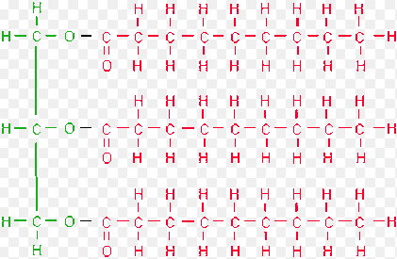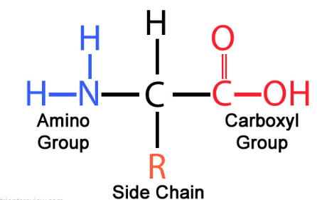

Reading the Periodic Table

Equal to the number of protons in the nucleus, as well as the number of electrons in the electron cloud

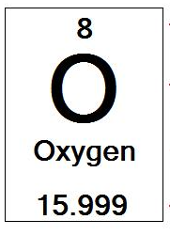

The sum of the numbers of protons and neutrons in a specific Isotope.

A one or two letter abbreviation derived from the element’s name

Elements common name

Weighted average of the masses of the element’s isotopes